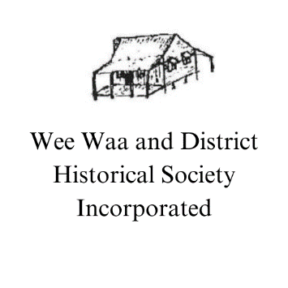
MEMBERSHIP FORM
Single - $10 per year
PO Box 516
Wee Waa NSW
Email: namoiechomuseum@gmail.com
NAME:

ADDRESS:

PHONE:

EMAIL:

PAYMENT: | $10
DONATION:

TOTAL:

SIGNATURE:

I WOULD LIKE TO RECEIVE THE NEWSLETTER POSTED/EMAILED TO THE ABOVE ADDRESS YES/NO

FOR NEW MEMBER
SIGNATURE OF PROPOSING MEMBER

OFFICE USE
RECEIPT NO:

PAYMENT BY DIRECT DEBIT TO ACCOUNT: BSB 012-865
ACCOUNT NO: 2 3484 5057
REFERENCE USED:

